Monitoring / On-Call Approval Form

Employee Name: Nik Adhaduk _
Manager Name: Vlad Rabenok .
Monitoring Hours
Date of Monitoring (mm/dd/yyyy) | Project | Reason | Number of Hours
Week of Feb 26th | Scene+ |  | 2
Week of March 5 | Scene+ |  | 2
Week of March 12 | Scene+ |  | 2
Week of March 19 | Scene+ |  | 2
Week of March 26 | Scene+ |  | 2
TOTAL |  |  | 10

On-Call Payment
Dates On-Call (mm/dd/yyyy – mm/dd/yyyy) | # of Weeks | Rate
 | 1
 | 1
 | 1
 | 1
 | 1
TOTAL

Approvals
Employee Signature:  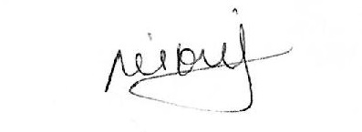 | Date:  26 March 2023
Manager Signature: | Date:

Please submit to Payroll once approved.

